Marta Devia  
Universidad Nacional de Colombia

**Rother, Leopoldo (1894–1978)**

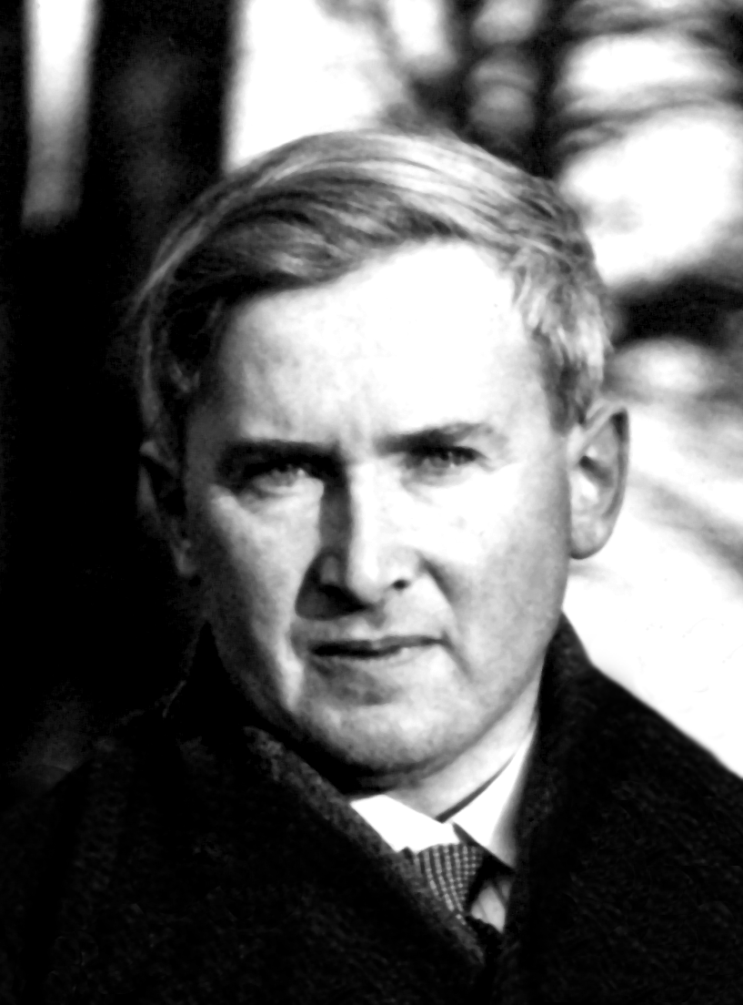

Although German by birth, Leopoldo Rother was a Colombian architect who exerted a great influence in the development of Colombian modern architecture. Rother is known for his rationality which reflects his technical training, his great discipline, his extensive knowledge of construction techniques and his passion for the craft.

Rother began his studies in Karlsruhe, Germany, in 1913 and received the title of architect–engineer in 1920 from the *Technische Hochschule Zu Berlin*. From 1920 to 1935 Rother worked for the German government. The design of several buildings for the University of Clausthal gave him a solid basis for his subsequent works in Colombia.

In 1935, due to his jewish descent, Rother had to seek refuge in Colombia where he spent the rest of his life.

At his arrival liberal presidents Alfonso López (1934-1938) and Eduardo Santos (1938-1942) had generated a profound political change in which education had a main role. The *Ciudad Universitaria*, campus of the *Universidad Nacional de Colombia*, was the great initiative which that political scene produced, integrating in one sole project policies, science, humanism and arts.

Rother sinthesized the educational approaches of the German pedagogue Fritz Karsen in the plans of the *Ciudad Universitaria*. As in a great laboratory of modern architecture, Rother participated with a group of talented architects from different countries, including Albert Wills, Eusebio Santamaría, José María Plata, Bruno Violi and Ernesto Blumental. In a large tract of land in the outskirts of Bogota, academic, administrative and sports scattered buildings were projected. The geometry of the layout is that of a great oval, being the major axis a sequence composed of sports buildings to the North, a great central space surrounded by four great areas of knowledge –Arts, Humanities, Medical Sciences and Natural Siences- and administrative buildings to the South. Its urban design, with isolated buildings within parks, generated a great urban impact as the ideal of the modern city.

Rother designed 31 projects for the *Ciudad Universitaria*. Of these, 17 were actually built. The *Edificio para la Imprenta*, (1945–1948), which now houses the *Museo de Arquitectura Leopoldo Rother,* is the more significant: in this building two light concrete softly curved shells shelter the spaces which were intended for a printing workshop and now serve as exhibition spaces. One of its main internak features is a ramp which links the ground level with the main floor.

Working for the Ministry of Public Works, Rother designed several public buildings in other Colombian cities. Among these: the *Edificio Nacional* (1945–1952) in Barranquilla, and the *Plaza de Mercado* (1946–1950) in Girardot. Both projects are roofed by concrete shells which are the result of Rother’s technical expertise.

Rother also had a private practice of which several apartment buildings are the result. He was professor emeritus at the *Universidad Nacional de Colombia*.

**List of works**

Works in Germany:

1926–1930 *Aula Academica* and other buildings, Clausthal Technical University, Germany.

Works in Colombia:

1936–1956 Urban Plan, *Edificio para la Imprenta* and other buildings, *Ciudad Universitaria*, *Universidad Nacional de Colombia*, Bogotá.

1946-1952 *Edificio Nacional*, Barranquilla, Colombia

**References and further reading**

- ARANGO, S. *Historia de un Itinerario*, Editorial Unibiblos, Bogotá, 2003.

- ROTHER, H. *El Arquitecto Leopoldo Rother, Vida y Obra*, Editorial Escala, Bogotá, 1986

- ZALAMEA, J., KARSEN, F. et al. *Ciudad Universitaria de Bogotá*, Revista de las Indias, Primera Época Volumen 1. Nº 6, Bogotá, julio de 1937

- DEVIA DE JIMENEZ M. *Leopoldo Rother en la Ciudad Universitaria*, Editorial Escala, Bogotá, 2004

**Visual material:**

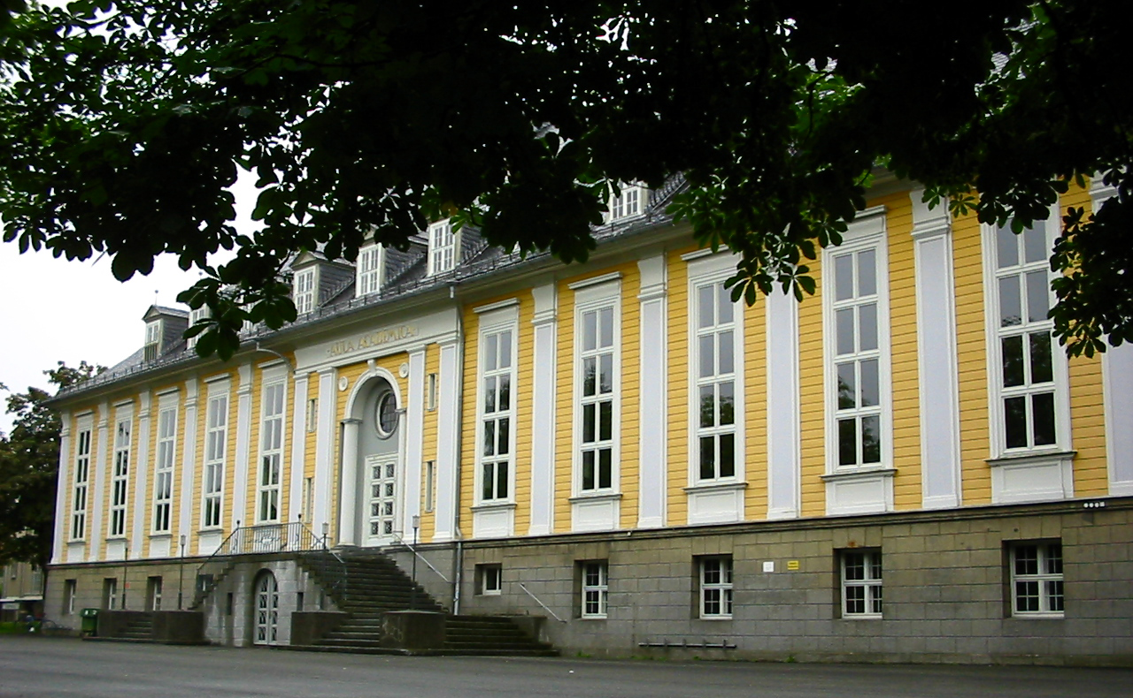

*Aula Academica*, University of Clausthal, Zellerfeld, Germany, 1927

Copyright: Marta Devia

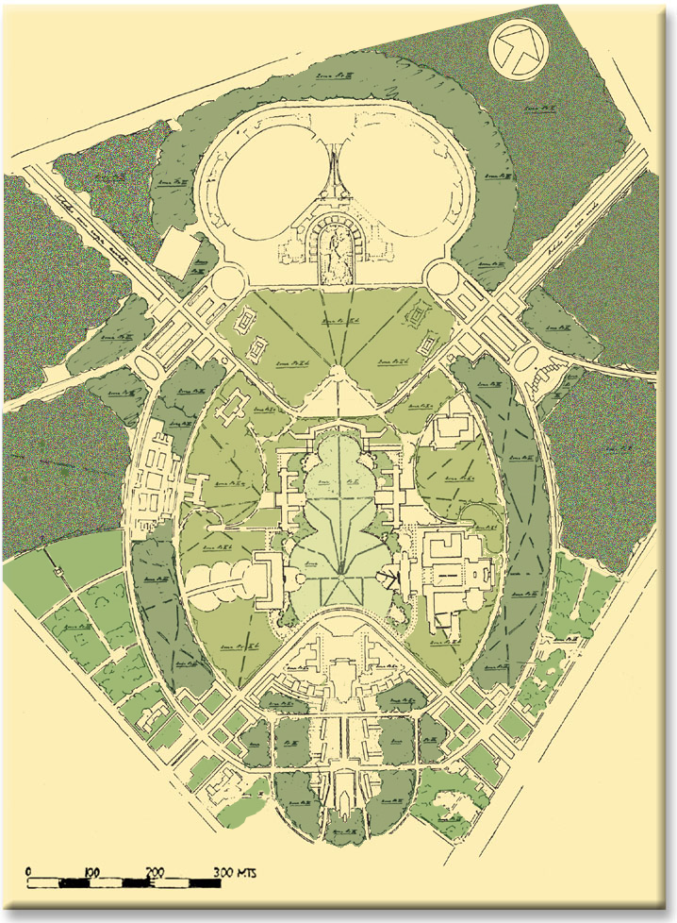

Master plan*, Ciudad Universitaria*, Bogota, Colombia, 1940

Copyright: Museo de Arquitectura Leopoldo Rother

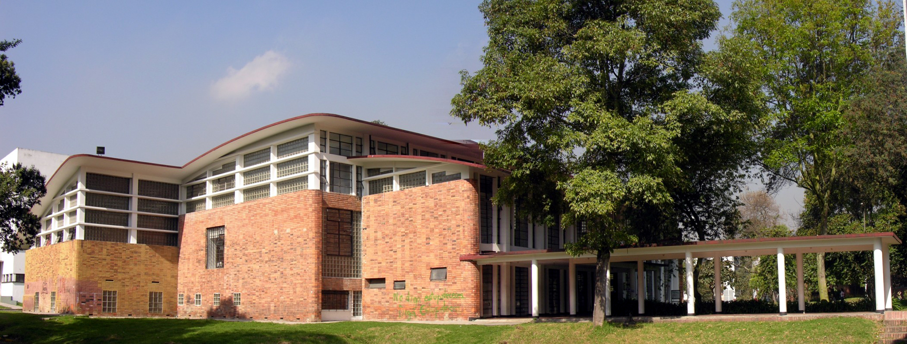

*Edificio para la Imprenta, Ciudad Universitaria*, Bogota, Colombia, 1945–1949

Copyright: Camilo Páez

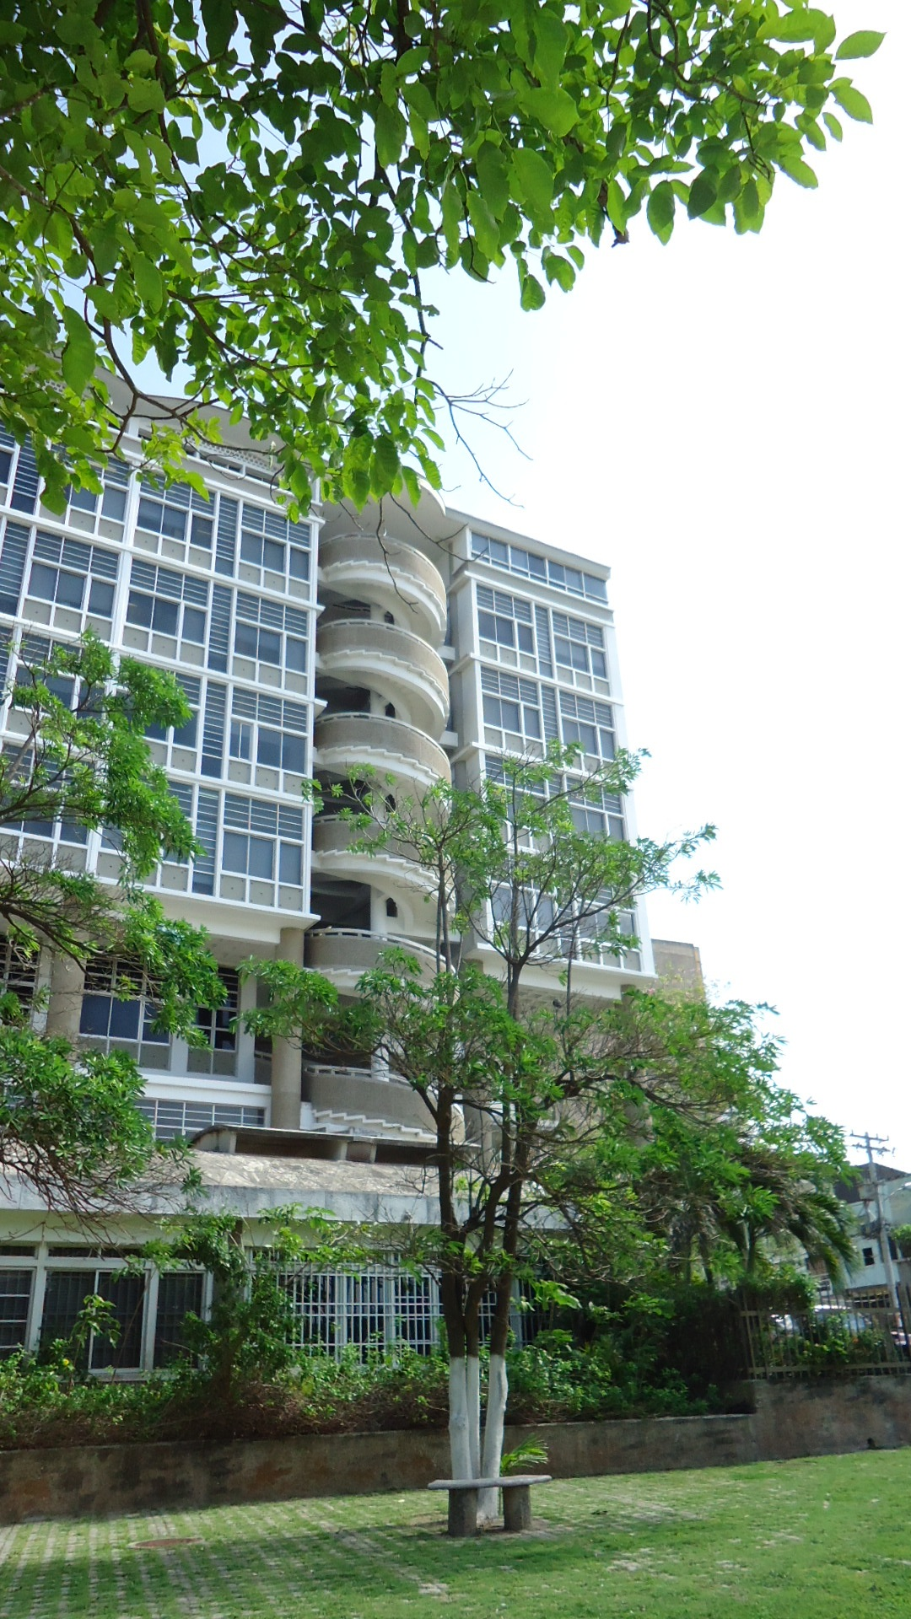

*Edificio Nacional,* Barranquilla, Colombia, 1946–1952

Copyright: Marta Devia